To: | City Executive Board
Date: | 18 December 2018
Report of: | Acting Head of Planning Services
Title of Report: | Annual Monitoring Report 2017/18

Summary and recommendations
Purpose of report: |  | To approve the Annual Monitoring Report for publication.
Key decision: |  | No
Executive Board Member: |  | Councillor Alex Hollingsworth, Planning and Regulatory Services
Corporate Priority: |  | A Vibrant and Sustainable Economy  Meeting Housing Needs  Strong and Active Communities  A Clean and Green Oxford  An Efficient and Effective Council
Policy Framework: |  | The Annual Monitoring Report is a statutory requirement providing information as to the extent to which the policies set out in the Local Plan are being achieved and the implementation of the Local Development Scheme. The scope of those policies is wide and encompasses all of the Council’s corporate priorities.
Recommendation(s):That the City Executive Board resolves to:
1. | Approve the Annual Monitoring Report 2017/18 for publication; and
2. | Authorise the Acting Head of Planning Services to make any necessary additional minor corrections not materially affecting the document prior to publication.

Appendices
Appendix 1 | Annual Monitoring Report 2017/18
Appendix 2 | Risk Assessment

Introduction and background
- The Annual Monitoring Report (AMR) 2017/18 assesses the effectiveness of planning policies contained within Oxford’s Local Plan as well as the implementation of the Local Development Scheme, Statement of Community Involvement and the Duty to Cooperate. The AMR also includes Community Infrastructure Levy (CIL) reporting. The AMR covers the period 1st April 2017 to 31st March 2018 and is a factual document.
- Section 35 of the Planning and Compulsory Purchase Act 2004 requires local planning authorities to publish monitoring reports at least yearly in the interests of transparency.
- The AMR provides feedback to Members, stakeholders and residents on the performance of planning policies and whether the objectives of those policies are being achieved. In doing so, monitoring enables the City Council to respond more quickly to changing priorities and circumstances. In addition, statutory plans are assessed at independent examination on whether the policies are founded on robust and credible evidence, and whether there are clear mechanisms for implementation and monitoring.
Findings of the 2017/18 Annual Monitoring Report
- The performance of planning policies is monitored using a traffic-light approach. Performance in 2017/18 is summarised in Table 1.

 |  | Targets and objectives have been met / data indicates good progress towards meeting targets. | Limited progression towards meeting targets / insufficient information to make an assessment. | Data indicates under-performance against targets and objectives.
A Vibrant and Sustainable Economy |  | 4 | 1 | 1
Meeting Housing Needs |  | 4 | 4 | 0
Strong and Active Communities |  | 3 | 0 | 0
A Clean and Green Oxford |  | 8 | 1 | 0
An Efficient and Effective Council |  | N/A – Traffic lights are not used to monitor progress in this section as there are no fixed targets.
Table 1: Summary of performance against targets 2017/18

- Overall performance in 2017/18 is positive, with the majority of indicators scoring green ratings for meeting or making considerable progress towards targets.
A Vibrant and Sustainable Economy
- AMR indicators show that current policies are providing strong protection for existing protected key employment sites.
- 10,447m² of new B1 employment floorspace was permitted during the 2017/18 monitoring year. Whilst this does not exceed the annual Corporate Plan target of 15,000m² each year between 2016 and 2020, permission for new B1 employment floorspace on average over the last two monitoring years is 15,610m² meaning the Council is still on track in meeting its targets. There has also been continued investment in new medical research and hospital healthcare facilities in Oxford during the monitoring year, with 1,393m² of new floorspace permitted during 2017/18. Whilst not as high as the 60,228m² permitted in the previous monitoring year it is still positive. Oxford’s employment land supply will be reviewed further as part of the work on the emerging Oxford Local Plan 2036.
- Planning permission was granted for six developments that would result in new A1 retail floorspace totalling 1,486m² in 2017/18, if implemented. Four out of six of these applications were located on sites that do not fall within Oxford’s retail hierarchy and therefore did not comply with the locational requirements of Policy CS31. These four applications combined represent a total net increase in A1 floorspace of 1134m² which is fairly significant. There was one proposal for new retail floorspace within the Summertown district centre comprising 285m², and one for 67m² in a Primary District Centre however this only represents 24% of gross new A1 floorspace approved in the 2017/18 monitoring year. This indicator is intended to help monitor whether developments which attract substantial numbers of people are suitably located. In this case over 600m² of the approved floorspace was for extensions to existing retail parks which are unlikely to negatively impact the City’s centres. Another 324m² of retail floorspace approved lies just outside the main shopping area and is within the City Centre commercial area and on balance considering this and its previous use as a marketing suite for a now complete development, the proposal was considered acceptable. The 100% target was not met during this monitoring year however this was for good planning reasons.
- Only one (Cowley Centre) of Oxford’s city and district centres met the Local Plan targets for A1 (retail) uses on designated frontages in the city and district centres, however the majority of centres were close to their targets. In terms of changes from the previous year, increases in the proportion of A1 retail units were found in Cowley Centre and in Headington, whilst East Oxford-Cowley Road and Summertown each decreased slightly.
- In recent years, additional permitted development rights have been introduced by central Government allowing A1 retail uses to change, temporarily or permanently, to other specified uses without the need for planning permission (although prior approval is required in some cases). This means that it is slightly more difficult to control the proportion of A1 retail uses on Oxford’s designated street frontages through the planning system. However, this has not had a significant impact on Oxford’s designated frontages to date. The emerging Oxford Local Plan 2036 seeks to support the role that town centres play in Oxford and seeks to ensure that a significant retail presence is maintained at the ground floor level of Oxford’s city, district and local centres. The Revised NPPF (2018) continues to highlight the importance of the high street however it also highlights that centres should be responsive to changes in retail and leisure industries. The emerging policies remain adaptive to changes in the retail circumstances of Oxford’s centres going forward by taking an evidence based approach to future planning applications.
- The Retail and Leisure Study for Oxford (Carter Jonas, 2017) assesses the success, vibrancy and opportunities in the city centre and confirms that there are a significant number of retailers who are looking for a presence in Oxford that have not yet got premises. The Westgate Shopping Centre was completed and opened towards the end of the 017/18 monitoring year, which has significantly contributed towards the retail offer in the city’s commercial centre and also helped create additional jobs. This will reinforce the retail attraction of the city centre and will thereby support the retail hierarchy.
Meeting Housing Needs
- In the 2017/18 monitoring year, 282 (net) dwellings were completed in Oxford. Whilst this is some way off the 400 dwellings per year annualised target set in the Core Strategy, the average annual housing delivery since 2006/07 remains above the 400 dwellings per year target. The cumulative number of dwellings completed in the 12 years since the start of the Core Strategy period (2006/07 to 2017/18) is 4,498 dwellings (net). The cumulative number of completions that might have been expected during this period is 5,250 dwellings (net). Therefore at the end of 2017/18 there were 752 fewer completed dwellings than might have been expected. This should be considered in the context of the 2007/08 financial crisis which had a dramatic impact on the house building industry for several years. It is also important to note that larger schemes are likely to take longer to implement and some of the larger schemes approved in the last couple years are unlikely to be completed in the same year they were approved in. Since 2014/15 the number of completions has steadily been increasing, and it is anticipated that any shortfall will be further addressed within the next few years, particularly as major schemes such as Barton Park are built out.
- The housing trajectory which calculates the expected number of homes to be built up to 2026 shows that Oxford City Council is likely to exceed its housing target set in the Core Strategy by 2024.
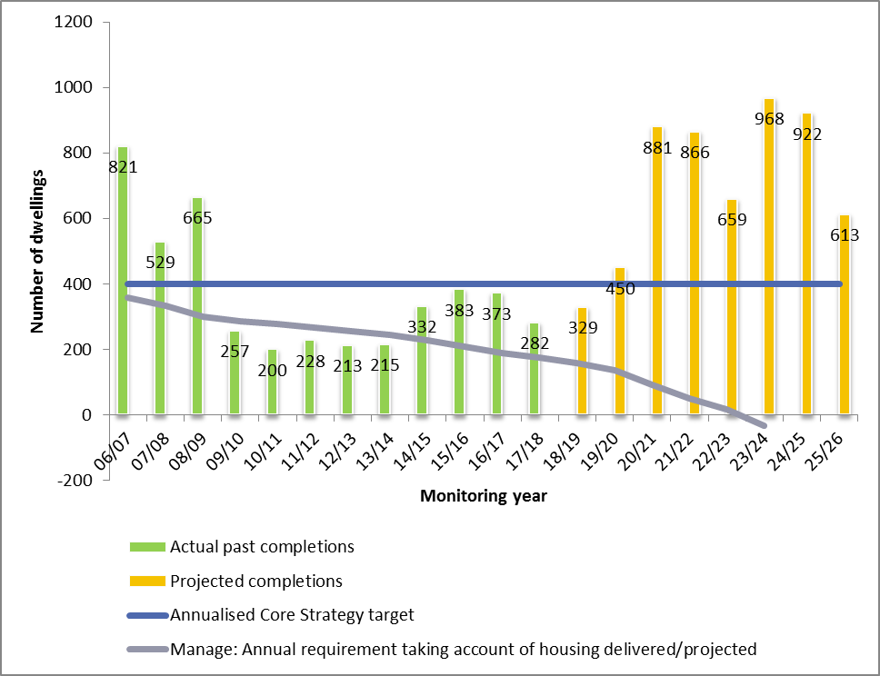

- 18 affordable dwellings (32 gross) were completed in 2017/18. The main contributors were 10 social rent dwellings at Marywood House, Leiden Road (14/01770/FUL) and 15 social rent dwellings at Northway Centre, Maltfield Road (12/03280/FUL), however 14 social rent dwellings were lost to enable development of the Westgate Centre which will bring jobs and increased retail offer to Oxford. As with the overall housing numbers for completions and permissions, it is natural for affordable housing delivery to fluctuate due to the limited number of larger sites available within Oxford. However, as mentioned above, affordable housing delivery is expected to increase in future monitoring years.
- The Council seeks to ensure that the tenure split of affordable housing be at least 80% social rented and up to 20% intermediate (including shared ownership, intermediate rental and affordable rental). 23 of the 32 affordable homes delivered were on a social rent basis meaning in total throughout the monitoring year 71% of affordable homes delivered were on a social rent basis. The 80% target was met on all applications except one (Northway Centre) which lowered the overall percentage for the monitoring year. On an application-by-application basis however the Council is achieving the 80:20 tenure split in most cases.
- In the 2017/18 monitoring year the City Council received £1,717,018.34 through s106 agreements towards affordable housing provision. This money will be used to support the delivery of affordable housing elsewhere.
- Core Strategy Policy CS25 requires each university to have no more than 3,000 full-time students living outside of university provided accommodation in Oxford and all increases in academic floorspace that would facilitate an increase in student numbers at the two Universities should be matched by an equivalent increase in student accommodation. Planning permission was granted for 3,225m² of new academic floorspace for The University of Oxford, however this was an application for a temporary building to deal with the closure of another building. Both the University of Oxford and Oxford Brookes University have exceeded their Core Strategy target in the 2017/18 monitoring year however permission was granted for a total of 1,978 new student rooms between the two universities.
- In 2017/18, the University of Oxford had 3,174 students living outside of university provided accommodation in Oxford. Oxford Brookes University had 4,089 students living outside of university provided accommodation in Oxford in 2017/18, a decrease of 91 students when compared to the previous monitoring year. This information was provided to the City Council in late August/early September 2018. This information would be a key consideration in determining any planning applications for new or redeveloped academic floorspace that may be submitted by the universities.
- Oxford Brookes University has commented that they have continued to exceed the 3,000 target due to an increasingly volatile higher education market and changes in student behaviour since the introduction of the £9,000 undergraduate fee in 2012. Oxford Brookes has identified that the proportion of students who decide to live in Oxford has increased from around 64% in 2010 to well over 70% in 2016, meaning that their residential halls (including university owned and those under nomination agreements) cannot meet this increased demand. (Further information is provided under Indicator 17 of the AMR, which is attached as Appendix 1.) It is anticipated that these trends are set to continue. Oxford Brookes University is therefore currently working on a fully revised student accommodation strategy, taking into account these fundamental shifts in the makeup of the student body and the consequential impact on the accommodation the University needs to provide to ensure it can meet the 3,000 target.
- In the 2017/18 monitoring year 472 (net) units of student accommodation were completed in Oxford. Planning permission was granted for a further 1,978 (net) units of student accommodation in 2017/18. In addition, a number of other student accommodation schemes have been considered by the City Council during the monitoring year:
Application | Site | Development | Total No. Rooms Net
16/02687/FUL | 265 - 279 Iffley Road And Garages  Percy Street  Oxford  Oxfordshire  OX4 4AH | Re-development of the application site to include the demolition of existing buildings, erection of buildings to provide student accommodation (117 student rooms) and ancillary facilities, 11 x self-contained flats, a single storey garden room accommodating flexible space for use as student common room/teaching/lecturing space, 150sqm GIA for employment uses (Use Class B1), and associated landscaping and infrastructure. (Amended plans) | 117
17/00418/FUL | 24 Norham Gardens  Oxford  OX2 6QD | Conversion of existing building from 3 x flats (Use Class C3) to provide 1no. bedsit and 11no. student bedroom (Sui Generis). | 11
16/03056/FUL | Balliol College Sports Ground  Jowett Walk  Oxford  OX1 3TN | Proposed demolition of existing collegiate accommodation and erection of C2 residential institution including sports pavilion, assembly space and associated accommodation, access and landscape.(amended information and revised plans) | 145
16/02997/OUT | Land Adjacent 2  Rymers Lane  Oxford  Oxfordshire  OX4 3LA | Application for outline planning permission for the provision of development comprising a purpose built student accommodation facility of 39 study bedrooms with ancillary facilities for use during academic term time and vacation periods, including means of access and scale. | 39
17/01230/FUL | 46 And 47 St Clement's Street  Oxford  Oxfordshire  OX4 1AG | Change of use from a House in Multiple Occupation (Use Class C4) and Housing in Multiple Occupation (Sui Generis) to Student Accommodation (Sui Generis). Demolition of existing single storey rear extensions and erection of a new single storey rear extension, Replacement windows and existing render to be repainted. Erection of single storey and two storey extension to existing outbuilding. Alterations to roof of existing two storey outbuilding. Insertion of windows and provision of access to first floor, Re-render existing brickwork and installation of timber cladding. Provision of bin and cycle store and formation of access from Caroline Street. (Amended Description) (Amended plans) | 16
16/01752/FUL | Land At Swan Motor Centre And To The East  Between Towns Road  Oxford  Oxfordshire  OX4 3LX | Redevelopment of site to provide purpose built managed student accommodation comprising 144 study rooms, provision for one commercial unit, and provision of an on-site management suite, together with associated landscaping and infrastructure (amended plans). | 144
17/00758/FUL | St Catherines College  Manor Road  Oxford  Oxfordshire  OX1 3UJ | Erection of 78 student bedrooms (4 with disabled access) arranged in clusters of 8, over three floors in three 'pavilion' style buildings connected by glazed stairwells; together with a three storey Graduate Centre, landscaping, flood compensation, and associated infrastructure; and including the demolition of staircase 23. | 78
16/02945/FUL | Oxford Business Centre  Osney Lane  Oxford  Oxfordshire  OX1 1TB | Demolition of units 1-15 Oxford Business Centre and redevelopment including erection of purpose built student accommodation with small-scale A1, A3, A4 and B1 units, with associated landscaping. | 514
17/02140/FUL | British Telecom  James Wolfe Road  Oxford  Oxfordshire  OX4 2PY | Demolition of existing buildings. Erection of new student accommodation comprising of 885 student rooms (of which 46 would be fully accessible), communal areas and amenity provision, associated cafe and shop, laundrettes, plant room and electricity substation, new vehicular and pedestrian access to James Wolfe Road and closure of existing, cycle parking, landscaping and new enclosures. Use of student accommodation outside term time by cultural and academic visitors and by conference and summer school delegates. | 885
18/00286/FUL | 181 Woodstock Road  Oxford  OX2 7NB | Change of use from student accommodation (Use Class C2) to single residential dwelling (Use class C3). Alterations to include removal of existing chimney stack; removal of rear external steel escape staircase; insertion of new cast iron soil pipe to side elevation; replacement of 2no. fire doors with windows to rear elevation; replacement of ground floor windows with bi-fold doors to rear elevation and formation of steps to new garden terrace at rear. | -9
17/02537/FUL | St Hilda's College  Cowley Place  Oxford  Oxfordshire  OX4 1DY | Proposed demolition of existing buildings and redevelopment comprising: erection of new building to provide student accommodation (59 bedrooms), porters lodge, middle common room, fellows' accommodation and academic and administrative offices; erection of new pavilion building; removal of existing porch to old hall building and provision of replacement; creation of new pedestrian access from Cowley Place; replacement bin and bicycle parking. | 38

- In 2017/18 the City Council has only granted planning permission for additional purpose-built student accommodation on sites that meet the locational requirements of the Sites and Housing Plan.
Strong and Active Communities
- Significant progress has been made towards delivering new homes at Barton Park. Phase 1 of the development (237 dwellings) commenced on site in January 2017. Phase 1 includes 40% affordable housing (95 units), all of which will be provided as social rent. Two further reserved matters applications for community sports facilities and a community sports pavilion were approved in April and December 2016. Work is on-going to bring forward the subsequent phases of development. The delivery of Barton Park will help to support the regeneration of the wider Barton and Northway areas. The first homes were marketed for sale in September 2017, with the first residents moving into Phase 1 of the development in July 2018. Work is on-going to bring forward the subsequent phases of development. In February 2018, Grosvenor announced house builder Redrow Homes had been appointed to deliver over 200 further dwellings for the second phase of the development.
- Northern Gateway Development: Although outside this monitoring period, a planning application has come forward for the majority of the Northern Gateway Area Action Plan site. The application, reference 18/02065/OUTFUL, was received and validated on 31 July 2018 and is a hybrid application consisting of an outline and full application. The outline application is for up to 87,300sqm of employment space, up to 550sqm of community space, up to 2,500sqm of Use Class A floorspace, up to a 180 bedroom hotel and up to 480 residential units as well as associated works, including the provision of a new link road between the A44 and A40 and an energy sharing loop. The full part of the application is for 15,850sqm of employment space and associated works. The application has been made by Thomas White (Oxford) and the development is being referred to as Oxford North.
- The Oxpens SPD was adopted in 2013. Oxford West End Development Limited (‘OXWED’), a joint venture between Oxford City Council and Nuffield College has been formed to deliver the development of this site. The site could deliver up to 500 new homes; retail; up to 10,400m² of B1a offices and B1b research and development floorspace; a hotel with around 155 bedrooms; and student accommodation. An application (16/02945/FUL) for student accommodation with 500 rooms and small-scale retail and office units went to planning committee in March 2017; planning committee resolved to grant permission subject to legal agreements. Since permission was granted in 2017, demolition work for the Student Castle Scheme has now commenced on site with the intention of completion in 2020. Additionally, OXWED has gone to the open market to seek a development partner for the wider masterplan area. It is anticipated the development partner will be in place by the end of 2018.
- Work on bringing forward the redevelopment of Oxford train station continued during 2017/18. The Supplementary Planning Document (SPD) builds on work carried out for the Oxford Station Masterplan and an architectural competition held in 2016. The City Council produced a Draft Oxford Station Supplementary Planning Document (SPD) that was consulted on during summer 2017. Following this consultation, the Oxford Station SPD was adopted in November 2017.
A Clean and Green Oxford
- Planning policies are continuing to protect and enhance Oxford’s natural environment. There has been no loss of public open space or areas of biodiversity importance during 2017/18.
- Planning policies are effectively ensuring onsite renewable energy generation on qualifying schemes with 20% on-site renewable energy generation being achieved on all qualifying sites in 2017/18.
- The only indicator where the target has not been met relates to planning appeals where conservation areas were cited as a reason for refusal. Eight appeals were determined in 2017/18 where these policies were cited as one of the reasons for refusal. Of these five were dismissed (63%). In the three cases where the appeals were upheld, the Inspector determined that the proposals would not result in overall harm to the heritage context.
An Effective and Efficient Council
- Work on the emerging Oxford Local Plan 2036 has continued during 2016/17. The Local Plan will provide a long-term planning framework to deliver the managed growth of Oxford to 2036. This is an exciting opportunity to review planning policy aspirations and strategies to best meet the current and future needs of the city. The preferred options consultation was carried out in Summer 2017 in line with the LDS timescales. Following the close of the consultation the results were summarised and taken into consideration in the production of the Oxford Local Plan Proposed Submission Document.
- The City Council has continued to engage in on-going, constructive collaboration with neighbouring authorities and other statutory bodies as required under the Duty to Cooperate. This includes engagement in relation to the new Oxford Local Plan 2036 and active involvement in a number of on-going joint-working and partnership relationships. The Growth Board is working to address Oxford’s unmet housing (and affordable housing) need. A ‘working assumption’ of 15,000 dwellings of unmet need for Oxford has been agreed, as has an apportionment of how this should be divided between the Oxfordshire districts by 2031.
- CIL receipts for the 2017/18 monitoring year totalled £4,995,586, whilst expenditure of CIL receipts totalled £1,115,761.
- As of 1 April 2018 the City Council held £3,827,314 of developer funding which is due for expenditure (subject to Council approval).
Environmental Impact
- There are no environmental implications arising from this report, however the AMR does report on environmental issues such as biodiversity, energy efficiency and compliance with the Natural Resources Impact Analysis (NRIA) requirements.

Financial implications
- There are no financial implications arising from this report, however the AMR does report on the collection and spending of monies through the Community Infrastructure Levy (CIL) and s106 developer contributions.

Legal issues
- The preparation and publication of the AMR is a statutory requirement, as set out in Appendix B of the AMR.

Level of risk
- A risk assessment has been undertaken and the risk register is attached (Appendix 2). All risks have been mitigated to an acceptable level.

Equalities impact
- There are no equalities impacts arising from this report.

Report author | Amanda Ford
Job title | Team Leader, Planning Policy
Service area or department | Planning Policy, Planning Services
Telephone | 01865 252229
e-mail | aford@oxford.gov.uk

Background Papers: None

Planning application reference 16/02945/FUL (Oxford Business Centre)

